**Python – Retrieving data from a database – Practice questions**

1. Retrieve the first row (all columns) from the department table and print it to the screen as follows:



Solution

**import** sqlite3  
db = sqlite3.connect(**'u:/sqlite/teaching.db'**)  
cursor = db.cursor()  
sql_query = **"SELECT * \**

**FROM dept"**cursor.execute(sql_query)  
emp_row = cursor.fetchone()  
print(emp_row)  
db.close()

1. Retrieve all columns and rows from the emp table and print each row without any formatting as follows:

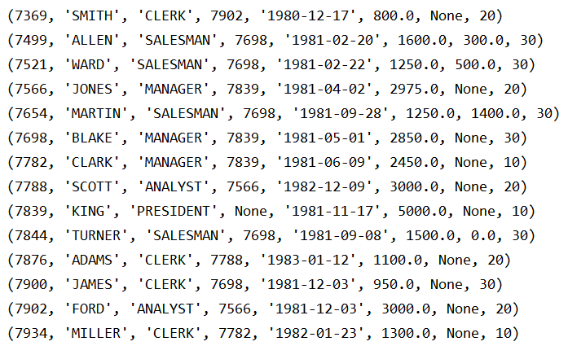

Solution

**import** sqlite3  
db = sqlite3.connect(**'u:/sqlite/teaching.db'**)  
cursor = db.cursor()  
sql_query = **"SELECT * \**

**FROM emp"**cursor.execute(sql_query)  
all_emp_rows = cursor.fetchall()  
**for** emp_row **in** all_emp_rows:  
 print(emp_row)  
db.close()

1. Retrieve the employee number, employee name and department no from the emp table and print the three columns separated by tabs as follows:

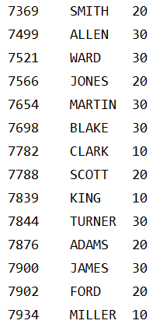

Solution

**import** sqlite3  
db = sqlite3.connect(**'u:/sqlite/teaching.db'**)  
cursor = db.cursor()  
sql_query = **"SELECT empno, ename, deptno \**

**FROM emp"**cursor.execute(sql_query)  
all_emp_rows = cursor.fetchall()  
**for** emp_row **in** all_emp_rows:  
 empno = emp_row[0]  
 ename = emp_row[1]  
 deptno = emp_row[2]  
 print(**'{0}\t{1}\t{2}'**.format(empno, ename, deptno))  
db.close()

1. Modify the code for question 3 to print each employee with a record number and save each employee number in a list. Then accept input of an integer (n) and print the nth employee number in the list (remembering that the first item in the list is 0)

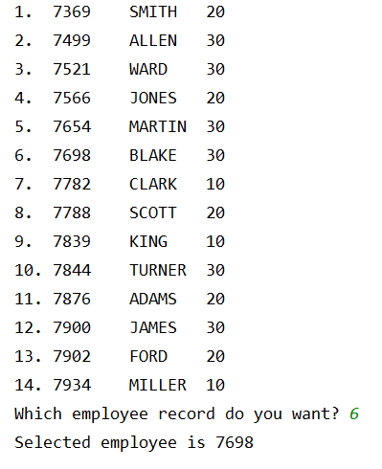

Solution

**import** sqlite3  
db = sqlite3.connect(**'c:/sqlite/teaching.db'**)  
emp_list = []  
i = 1  
cursor = db.cursor()  
sql_query = **"SELECT empno, ename, deptno \  
 FROM emp"**cursor.execute(sql_query)  
all_emp_rows = cursor.fetchall()  
**for** emp_row **in** all_emp_rows:  
 empno = emp_row[0]  
 ename = emp_row[1]  
 deptno = emp_row[2]  
 emp_list.append(empno)  
 print(**'{0}.\t{1}\t{2}\t{3}'**.format(i, empno, ename, deptno))  
 i = i + 1  
db.close()  
num_in_list = int(input(**"Which employee record do you want? "**))  
sel_emp = emp_list[num_in_list-1]  
print(**"Selected employee is"**,sel_emp)

1. Accept input of an employee name and retrieve the employee name and monthly_sal for that employee (with two decimal places and prefixed by a £) and print the details as shown below. Take account of the fact that the user may enter the name in lowercase. If the user enters an invalid employee, print “No employee found with that name”





Solution

**import** sqlite3  
db = sqlite3.connect(**'u:/sqlite/teaching.db'**)  
cursor = db.cursor()  
empname = input(**"Enter an employee name to display: "**)  
sql_query = **"SELECT ename, monthly_sal \**

**FROM emp \**

**WHERE UPPER(ename)=UPPER(?)"**cursor.execute(sql_query, (empname,))  
emp_row = cursor.fetchone()  
**if** emp_row:  
 ename = emp_row[0]  
 monthly_sal = emp_row[1]  
 print(**"Employee {0} earns a monthly salary of {1:.2f}"**.format(ename, monthly_sal))  
**else**:  
 print(**"No employee found with that name"**)  
db.close()

1. Accept input a department number and a monthly salary and display the department number, employee name and monthly salary of all employees who are working in the entered department and who have a monthly salary greater than or equal to the entered salary. If no rows are returned by the query, display “No employees found”

Solution

**import** sqlite3  
db = sqlite3.connect(**'c:/sqlite/teaching.db'**)  
cursor = db.cursor()  
dept = input(**"Enter a department number: "**)  
salary = int(input(**"Enter a minimum monthly salary: "**))  
sql_query = **"SELECT deptno, ename, monthly_sal \  
 FROM emp \  
 WHERE deptno=? \  
 AND monthly_sal>=?"**cursor.execute(sql_query, (dept,salary))  
all_emp_rows = cursor.fetchall()  
**if** all_emp_rows:  
 **for** emp_row **in** all_emp_rows:  
 deptno = emp_row[0]  
 ename = emp_row[1]  
 monthly_sal = emp_row[2]  
 print(**"{0}\t{1}\t{2}"**.format(deptno, ename, monthly_sal))  
**else**:  
 print(**"No employees found"**)  
db.close()

1. Retrieve the name of the sales reps and the names of all the customers they look after. Print the output as follows:

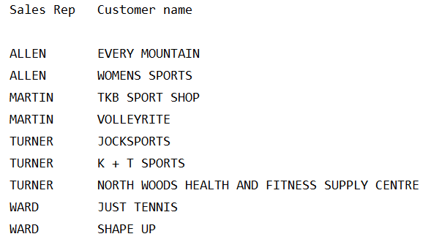

Solution

**import** sqlite3  
db = sqlite3.connect(**'u:/sqlite/teaching.db'**)  
cursor = db.cursor()  
sql_query = **"SELECT ename, name \  
 FROM customer c \  
 INNER JOIN emp e ON c.repid = e.empno \  
 ORDER BY ename"**cursor.execute(sql_query)  
all_rows = cursor.fetchall()  
print(**"Sales Rep\tCustomer name\n"**)  
**for** row **in** all_rows:  
 repname = row[0]  
 custname = row[1]  
 print(**"{0}\t\t{1}"**.format(repname, custname))  
db.close()

1. Modify the code from question 7 to only print the sales rep name if it is different to the previous line e.g.

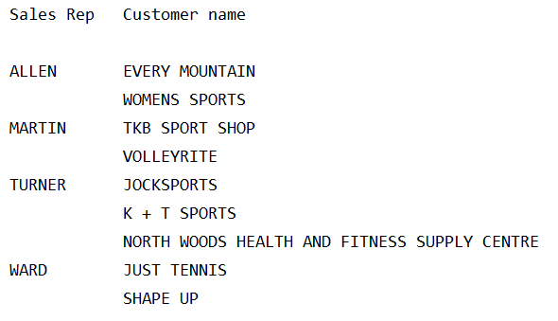

Solution

**import** sqlite3  
db = sqlite3.connect(**'u:/sqlite/teaching.db'**)  
cursor = db.cursor()  
sql_query = **"SELECT ename, name \  
 FROM customer c\  
 INNER JOIN emp e ON c.repid = e.empno \  
 ORDER BY ename"**cursor.execute(sql_query)  
all_rows = cursor.fetchall()  
last_repname = **""**print(**"{0:10}\t{1:40}".format("Sales Rep","Customer name"**))  
**for** row **in** all_rows:  
 repname = row[0]  
 custname = row[1]  
 **if** repname != last_repname:  
 print(**"{0:10}\t{1:40}"**.format(repname, custname))  
 last_repname = repname  
 **else**:  
 print(**"{0:10}\t{1:40}"**.format(**"",**custname))  
db.close()